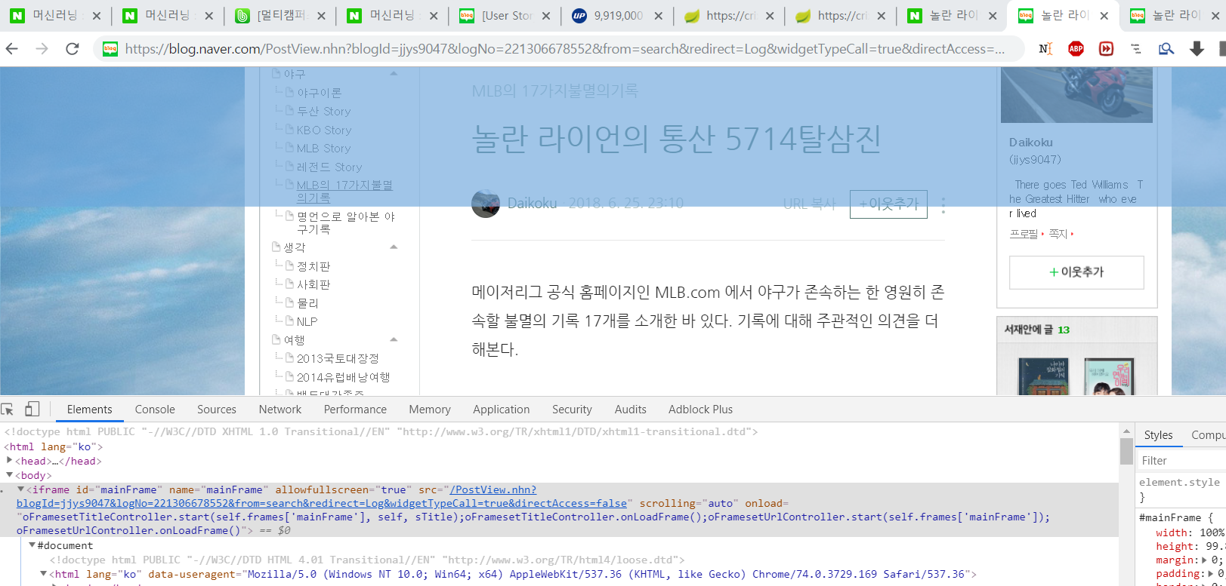src 값을 도메인 뒤에 써주면 원문이 나옴.

예) <https://blog.naver.com/jjys9047/221306678552>

->

<https://blog.naver.com/PostView.nhn?blogId=jjys9047&logNo=221306678552&from=search&redirect=Log&widgetTypeCall=true&directAccess=false>